Project goal: create a FOC-capable motor driver with an ESP32
- Chatting w/ Grego and hes been interested in making a universal motor driver so may want to add a 4th bridge to open up stepper compatibility
What do I want out of the project
- PCB design experience
- A device capable of driving motors in a fun application
  - Using E-bike as the target application since I suspect a driver that can drive an E-bike motor should be able to handle the power reqs of most things I would want to do in personal projects
  - Should be able to do position, velocity, or torque control (current control too maybe but I think current control is often a means to the end of torque control)
    - Requirements for controllability here are kind of hard to pin down for me. High-end of the application space is things like drones where you need to rapidly dynamically change motor speeds. For this project I’m leaning towards just build something and then testing it in post so see the limits of its ability to perform various dynamic motions. Fundamentally from the ESC perspective, being able to accurately drive rapidly changing currents on a variety of loads is what we are looking for here.
- A device for exploring FOC
  - Should include the necessary sensing for FOC (current+voltage sense on each phase)
  - Would be good to have peripheral interfaces for testing/validation sensors (hall)
  - Temp sensors? Could be good to have these as referents while also trying to implement observers to estimate them sensorless
- A device for exploring embedded RTOS
Why ESP32?
- Good dev board to explore wireless and RTOS
- Possible reasons to not use ESP32
  - Power hungry, especially when using wireless features
  - Have been told by Greg (and the internet) that the ADC is dogshit, would need an external ADC and then need to think about comm delay for things like FOC
  - Lower clock rate than most alternates (240MHz)
    - STM32 is very popular at 800MHz
    - RT1176 or similar is an industry powerhouse at 1GHz
    - 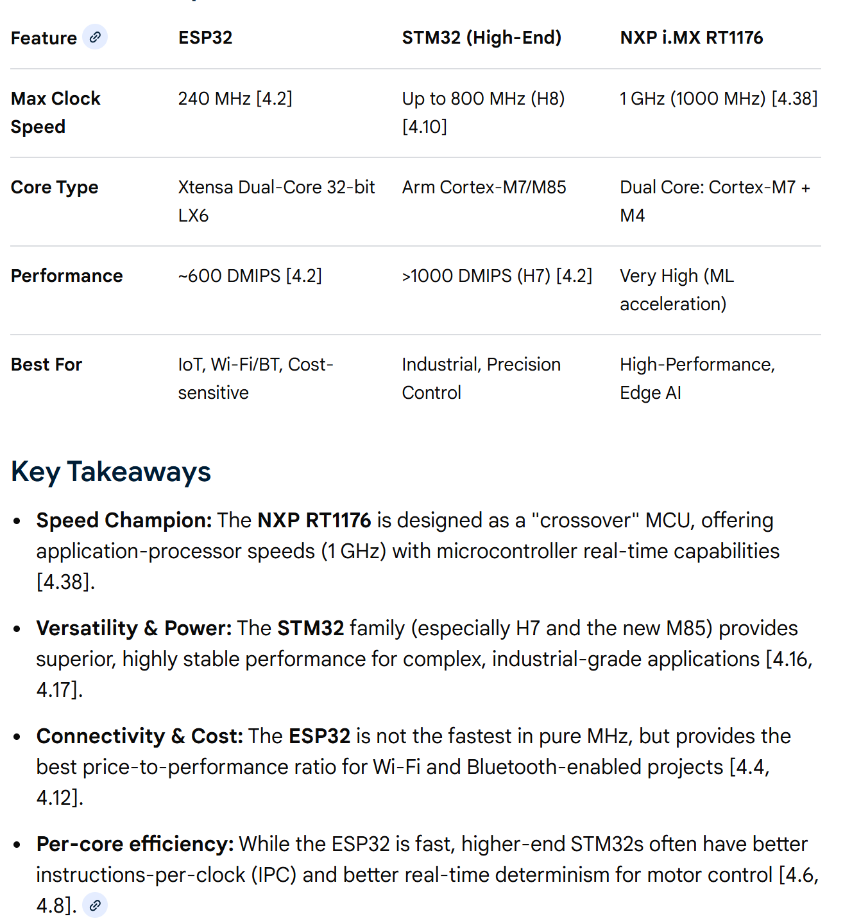
      - Note STM32 varies notably in family with lower end chips running 24 MHz
  - OK so the real question is: Why would I possibly limit myself in terms of control rate and battery life? Is the RTOS spool up and ease of wireless integration worth the possibility of running into a true performance limiter and needing to refactor the firmware for a new platform? Is the community support for ESP32 valuable enough to offset the risk of coming up short on performance?
      - The power concerns don’t worry me that much. For the purpose of FOC learnings I can run things in a benchtop setting with ready to swap batteries. For end applications I think motor loads are generally going to dominate microcontroller loads
      - The rate concern may be an important factor in how well I can implement FOC. This may be the limiting factor for dynamic movements. It would honestly be interesting to hit a processing speed limitation in my product, and may force me to think more deeply about clock speed/and control performance. While a possible pain in the ass, I think for the sake of learning I am willing to try this project on the slower MCU with better off-the-shelf RTOS support
        - Note from the future: 240MHz on a dual core processor should be totally fine for a FOC ESC. VESC uses a slower STM32.

Background research
General video for FOC with some coverage of observers in there
High-speed sensorless-FOC reference design for drone ESCs from TI
- Not really what I’m looking for re speed vs torque trade off here but maybe good reference for topology and concepts
- Temp estimates from winding resistance changes
- General schematic similar to what I’ve seen elsewhere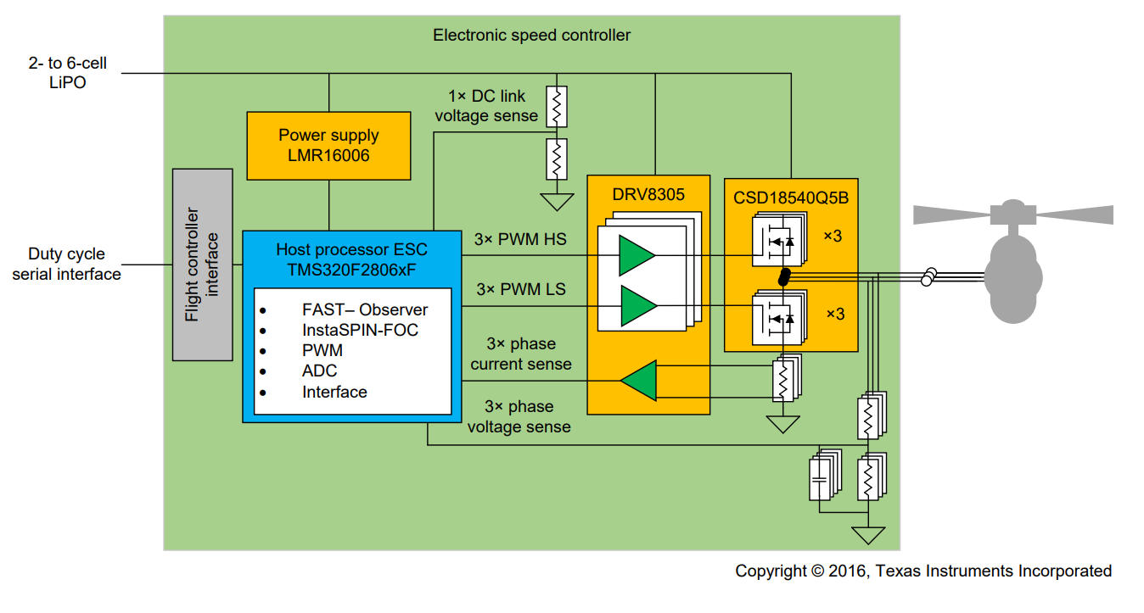
- High PWM frequency used to avoid noise in band of specific sensors (ultrasonic)
  - Takeaway: switching frequencies in my system may motivate filter design on analog sensors (current and voltage sense)
- TMS320 uses pre-existing observer algorithm. Might be nice to skip that implementation step but could rob me of some control theory learnings (could I write my own observer to get motor angle from current sensors?)
  - Might be useful to have a reference observer algorithm to compare my own to…
  - Would be a good shortcut to allow focus on the FOC algo to start
  - “The InstaSPIN-FOC algorithm is provided as a BSD-licensed open-source software package called MotorWare”
- TMS320F2806xF
  - Piccolo MCU – does this lock me into specific IDE choices that I may not like?
  - Built-in 10 bit ADC, internal voltage reg, high-res PWM drivers, supports ratiometric measurement with ADC
  - Big feature is preprogrammed control software in ROM for InstaSPIN-FOC
    - Supports sensorless FOC with FAST-observer
    - Closed loop current controller, auto motor ID’ing
  - Resistance change tracking
  - It’s an all-in-one control package that seems to do a lot of the work for me
- DRV8305 is not good for my application due to 45-V max operating voltage… I want to have 48V batteries be an option for future implementations
  - Important features for me:
    - MOSFET shoot-through prevention (don’t wanna short my batt rails)
    - MOSFET Vds overcurrent monitor
    - Over-temp protections?
- They use a power MOSFET
  - Possibly important features that I’d not thought of:
    - Avalanche rated (can handle high transient Vds caused by inductive switching – breaks down through body diode)
    - Chris always mentioned the mosfet SOA… Need to be sure we switch the FET quickly to avoid excessive heat production in the ohmic region
- Trade-off mentioned: higher PWM freq means less processing time for FOC and observer algos (unless we can use a multicore system or offload processing to peripherals)
  - They mentioned this in section 2.1.4, but I think a SPI PWM driver or something could save us here

VESC – hardware documentation
- Uses DRV8301 gate driver
  - https://www.ti.com/lit/ds/symlink/drv8301.pdf?ts=1771391440764
  - SPI interface for configuring, fault handling
  - 2x built in current sense amplifiers, but probably want 3 so will end up using a separate dedicated chip(s) for that
  - Built-in buck converter. Not clear on how to set output voltage but its designed to be 1.5A rated and used for mcu power so I think we can skip the battery -> mcu power conversion stage design elsewhere if we use this chip
    - Lets assume we output 5V from this and diode or it with USB power then LDO down to 3.3V for dat smooth usage
      - VESC does something similar but with a switch-mode buck from 5 to 3.3V. I like the idea of having the micro power generally be stable, but may need to reconsider if 3.3V loads are sizeable and LDO heating becomes an issue
  - 65V absolute max input (60V nom), probably decent with 48V nom Lithium batts. Can play around with 14S or smaller batts but may be limited in performance at lower SOCs
  - Includes shoot-thorugh prevention, overcurrent and overtempt protections (same as the DRV8305 mentioned above)
    - Overcurrent uses voltage across fets and a programmable setpoint to trip shutoff conditions. Would be interesting to actually intentionally trip this at some point if reasonable to do (can probably set the threshold low and stall a motor or something)
    - This is kind of like desat except desat specifically refers to when the fet leaves the saturation region (for IGBT or bipolars) or the ohmic region (for MOSFETs) while this allows protection to kick in at a lower, programmable Vds or Vce threshold (https://www.ti.com/lit/ab/slvag18/slvag18.pdf?ts=1771433135091&ref_url=https%253A%252F%252Fwww.google.com%252F)
  - Some undervoltage is not reported by the DRV8301 except through nFAULT pin
    - PVDD UV fault resets registers, there is oddity with 13-15us transients as well. In general, if we want to catch problematic undervoltage events, we should consider monitoring PVDD and GVDD on our own with ~10us period
    - nFAULT and nOCTW should tell us if we have an under or overvoltage event too… probably don’t need independent PVDD and GVDD monitoring but it may just be a generally good idea since this is pretty much battery voltage
  - Interesting note on bulk capacitance. The battery should eat most regen but parasitic inductance could still result in large local voltage spikes on inductive switching. Local capacitance near drive circuit could help keep local components from overvolting 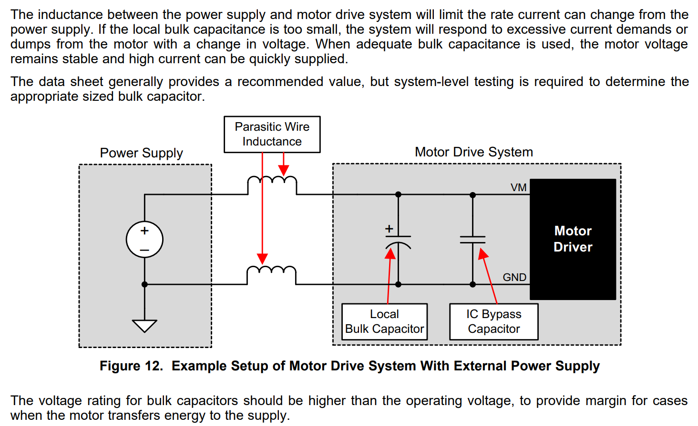
- Uses STM32 which is generally going to be a more performant microcontroller than the ESP32, but it will be harder to get off the ground with wireless and RTOS applications I think (ESP NOW might be useful for remote controllers or fun multi-motor coordination applications)
  - Actually in terms of clock rate the STM32F4 used is actually lower clock rate than ESP32 https://www.st.com/en/microcontrollers-microprocessors/stm32f4-series.html
  - Dhrystone million instructions per second (DMIPS) also lower/comparible to ESP32 cores (ESP32 gets extra bonus because its got 2 cores )
- CAN transceiver – fun feature to explore very industry relevant but not really necessary for my applications that I have in mind. Maybe throw this in if you have time, IO, and feel like adding flexibility
- Uses AD8418 current sense amplifiers on phase lines (not high or low side sense, directly sensing phase currents)
- Uses NRF24L01P transceiver for wireless comm (presumably for remote controllers)
  - Cool to see this option out there. ESP32 has wireless built in but im starting to wonder if power consumption and
- MPU-9150 directly integrated. This is a 9-axis IMU (accel, gyro, compass). Very fun, can imagine this being a great nice-to-have feature for lots of motion control applications down the line. I am likely also going to use this chip
  - VESC 6 plus uses MPU9250
  - VESC 6 mk5 uses BMI160
- VESC 6 plus and mk5 has togglable hardware filter for current sense and mk5 has togglable hardware filter on v sense
- IRF7749 MOSFET may not be good for sufficient current depending on temp conditions
  - VESC 75 300 uses multiple parallel IRF7759 on each leg, I think to improve current rating (also boosts voltage rating to 75V)
    - This may have been the cause of the additional half-bridge gate drivers UCC2721… also resulted in another buck converter for 12V supply… notable complexity bump would like to avoid this if possible
    - I wonder if there was switch time issues driving 3x MOSFET with just the DRV8301. Important note is to consider gate capacitances, available drive current, and switch times (SOA)
- No other surprises in the schematics, I think the general circuit topology is pretty standard

